1. **Install Power BI Desktop and share the final screenshot of the report view page which appears when power desktop starts.**

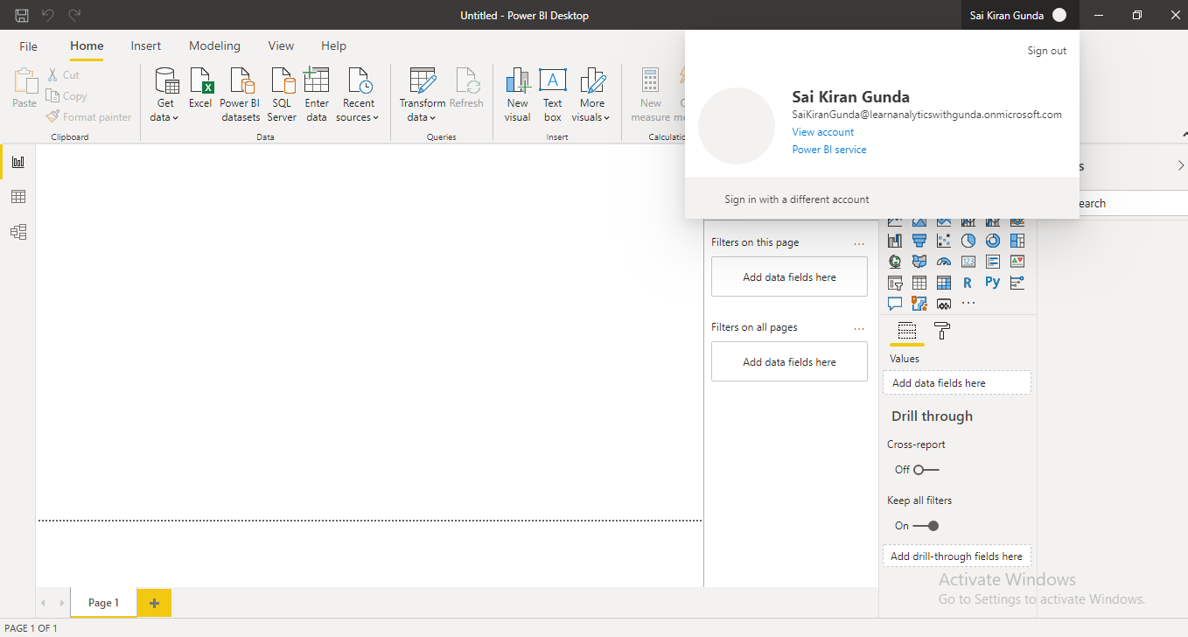

**2) Prepare a document and with the following screenshot**

**− Report View**

**− Data View**

**− Model View**

**− Power Query Editor**

**− Advance Editor**

**Answer)**

**- Report View:** This is the place where we create reports and visualize them by dragging column fields from the table (located at right side of view).

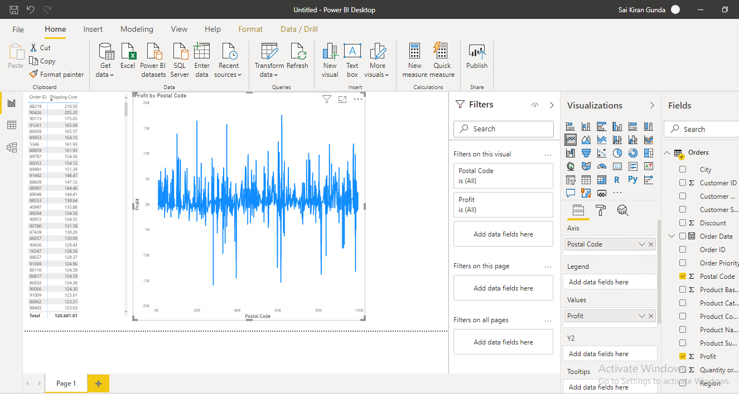

**− Data View:** Here we can see the data inside the tables for reference while preparing the reports.

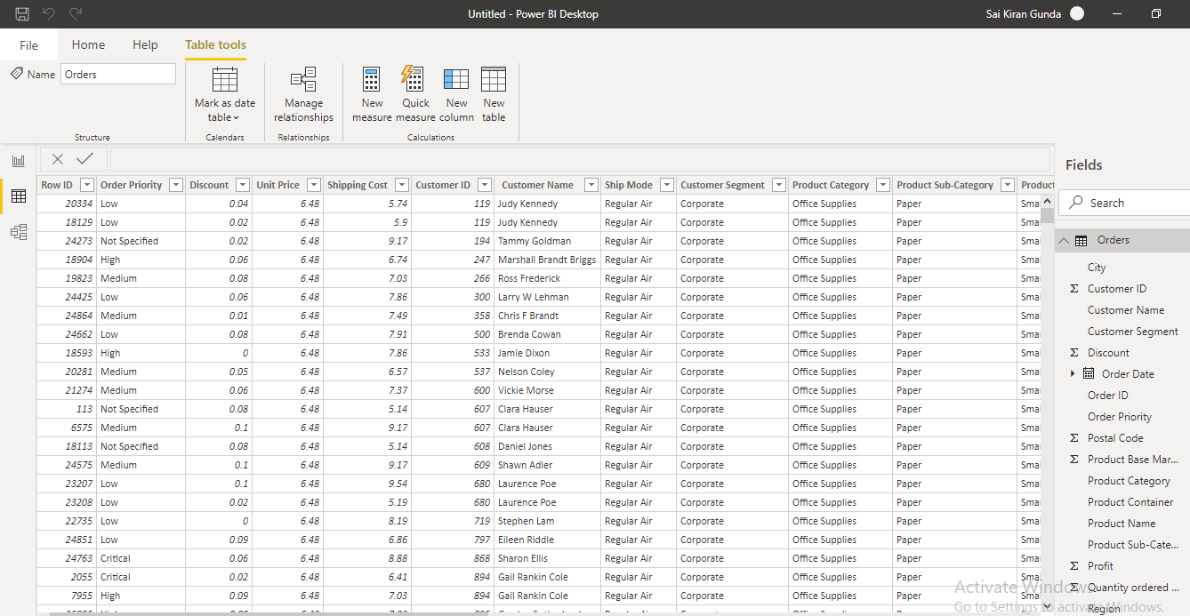

**− Model View:** Here we can see the relationships between the tables imported into the Power BI and we can create new relations as well.

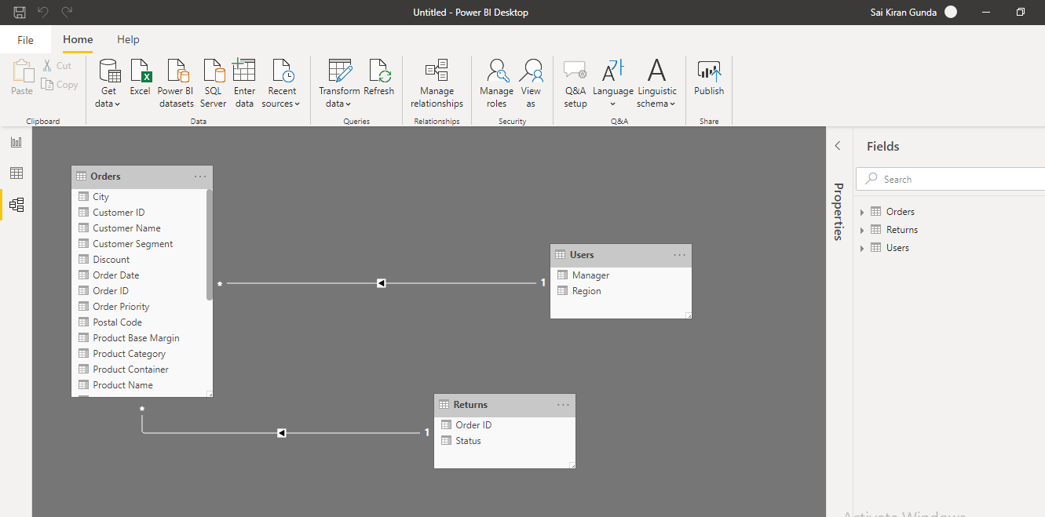

**− Power Query Editor:** This this is place where we actually clean and modify the data before proceeding to any visuals like deleting blank rows, creating proper headers to data, converting data types into required forms like Date, rounding of numbers, currency etc.

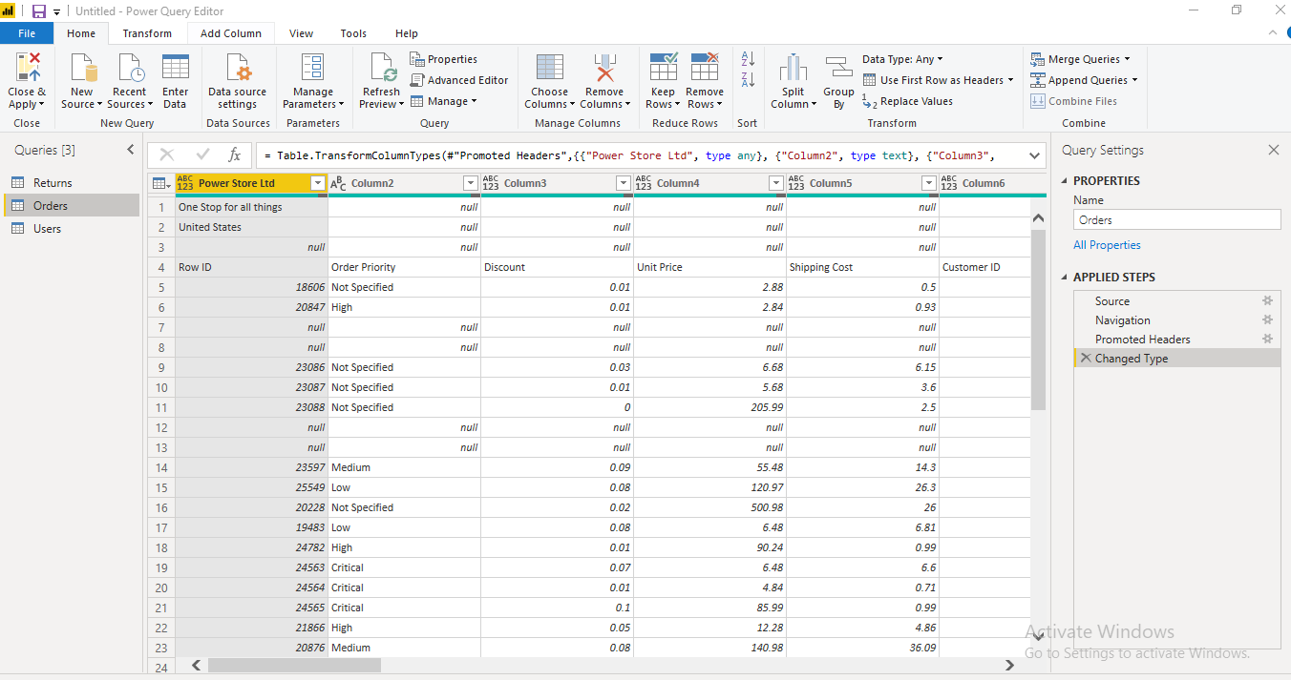

**− Advance Editor:** This is box where code will be written to our performed actions in the PowerBI. We can write code manually as instead of using drag and drop options.

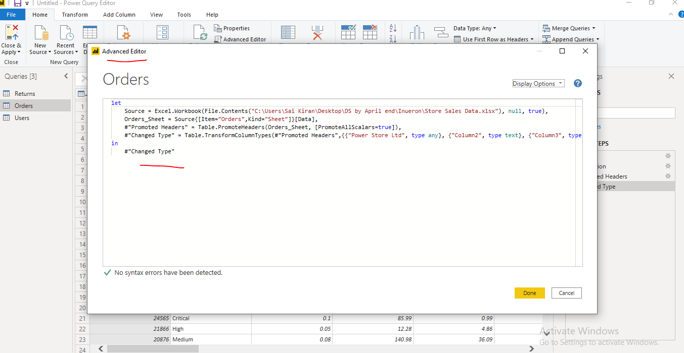

**3) Prepare a document with details of the following along with their price**

**− Power BI Desktop**

**− Power BI Pro**

**− Power BI Premium**

**Answer:**

**− Power BI Desktop**

* You can install locally into your system
* You can create dashboards, modify data
* You cannot share the files to others
* Data usage limit is 10GB
* Monthly price: Free

**− Power BI Pro**

* You can create dashboards, modify data
* Individual license is provided
* You can share your reports to others who have license
* It also integrates with other Microsoft products like office 365
* You can create App work spaces
* Data usage limit is 10GB
* Monthly price: $ 9.99

**− Power BI Premium**

* You can create dashboards, modify data
* Organizational license is provided
* You can deploy your reports into cloud environment
* You can share your reports to others in same organization easily
* It handles large volumes of data compared to Power Bi desktop and Pro
* Monthly price: $ 4995